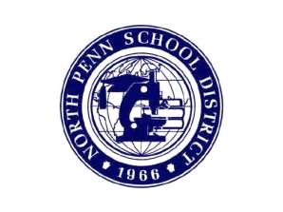
NORTH PENN SCHOOL DISTIRCT
REQUEST FOR PUBLIC TRANSPORTATION
2025-2026 Academic Year

Please complete the information below and return this form to your non public school only if your child would like to utilize transportation provided by the North Penn School District.

Child/Children’s Last Name ___________________Non-Public School________________

Regarding Act 372 (Non-Public School Busing by Public School Districts), my present requirements for the 2025-2026 school year are:
First Name Gender (M/F) Grade D.O.B.
______________________________________________________________________________

______________________________________________________________________________

______________________________________________________________________________

Parent(s) Name________________________Daytime Phone (___ )__________________

Address______________________________________ AM Only _____PM Only ______

_____________________________________________ BOTH AM & PM ____NONE _______

Email Address_______________________________________________

Please note: This form must be returned to your Non-Public School to be sent to the North Penn School District.

Important Information:
1) Most school districts do not transport Pre-Kindergarten students, regardless of their age.
2) Most school districts transport qualifying students in Grades K thru 12.
3) North Penn School Buses will not transport students that do not reside within the North Penn School District.

***** For assistance logging into Infinite Campus to get your student's transportation info, contact:
_npfamily@npenn.org

