

The Upper Perkiomen School District is currently transitioning into a new student information system, PowerSchool. All your current families have been rolled over into the new system. No extra work is needed for them during this transition.
All new students and all Kindergarten students, including those attending nonpublic schools, are required to enroll through our new system. This updated platform is designed to streamline the registration process and improve overall efficiency, while ensuring we have all the necessary emergency information for your families.
At this time, new families are only required to upload the two documents necessary for proof of residency during registration. Any other documents can be skipped. In addition, all new families—along with all current Upper Perk families—must complete the required Act 372 form. Here is the link to the live registration Upper Perkiomen PowerSchool Registration. The link and more information can be found on the UPSD Registration page. The Act 372 form below will remain on paper for this school year.
Please note that both the PowerSchool registration and the Act 372 form must be completed and submitted by July 1st. If these items are not received by the deadline, we cannot guarantee that transportation services will be in place for the first day of school.
We appreciate your cooperation in communicating this information to families and helping ensure a smooth start to the upcoming school year.
If you have any questions or need assistance, please do not hesitate to reach out. More information regarding registration and/or transportation can be found on the district website www.upsd.org.

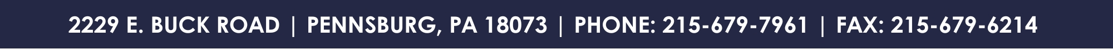


Request for Transportation Under Act 372
Non-Public and Charter School Students
(Please complete a separate form for each student)

Student Name: ___________________________________ DOB: ____________________
School Name: ____________________________________ Grade: ___________________
Home Address: ___________________________________
________________________________________________
Email Address: ____________________________________ Phone:__________________

Transportation Need (circle one) AM PM Both None Unknown

Start Date____________________

Parent Printed Name:_____________________________________
Parent Signature: ________________________________________ Date:_______________

- All students requiring bus transportation to and from their Non-Public or Charter school must be registered with the Upper Perkiomen School District and submit a completed Act 372 form, every school year.
- Please return all forms to Upper Perkiomen School District prior to July 1st, to ensure your child will receive transportation on the first day of school.
- We are not permitted to transport any students that are not residents of the Upper Perkiomen School District. Bus passes will not be issued for students to go to any location, other than their assigned stop.
- Students and parents should be aware that video equipment may be utilized on UPSD vehicles to monitor student behavior in order to provide a safe environment for all students.
- Please refer to the district website for a complete list of the rules and regulations; as well as inclement weather procedures. www.upsd.org

Upper Perk District Contacts:

Jenn Malone Kristal Bitner
Director of Transportation & Registration Administrative Assistant
jmalone@upsd.org kbitner@upsd.org
215-541-2443 215-541-2471

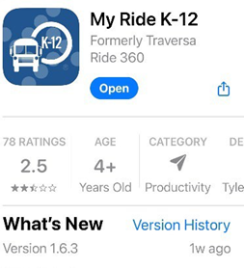

traversa
a tyler school solution
How to access the My Ride K-12 mobile application

1. Download “My Ride K-12” from the Google Play Store or the Apple App Store.

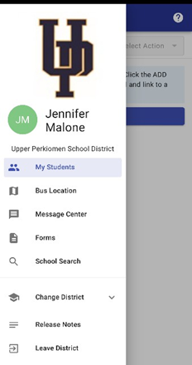
2. After the app installation is complete, open My Ride K-12.

3. When prompted to find your school district, search for Upper Perkiomen School District.

4. Once you have selected your district, you will proceed to the login page.
If you do not already have a registered email, click ‘Register’. If you were a user
last school year, your information is the same. The “forgot password” option is
working properly to reset your old password. Each school term, you will have
to relink your students.

5. To register for a new account: enter your email address, password, and name.

6. After registering, you will receive a confirmation email. Click on the link in your
email to confirm your registration through the My Ride K-12 website.

7. Log in the app, then find your student by going to My Students and choosing the + button.
This will present the Find a Student screen.
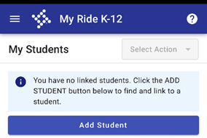
8. Enter the Student ID to find your student. Repeat this step to add additional students.
If you need assistance locating your Student ID, please contact your school or the
transportation department. Parent Square will also have Students IDs for all students.

9. Once you have linked to a student, click on that student’s profile to see all
relevant transportation information.
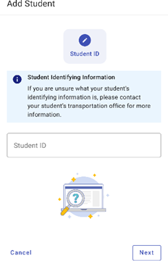
10. You may share your student(s)’ bus information with up to 5 contacts.
Just like you did, they must download and register with My Ride K-12. You will need to
share your student(s)’ ID number with them.

11. Regularly check for updates to ensure that your device is running the
latest version of the app.

12. Remain logged into the app to receive district notifications, even when the app
is not actively running. Do not disable notifications, you may miss important communications.

